3. Doctor Portal

3.1 Doctor Dashboard

[Code]
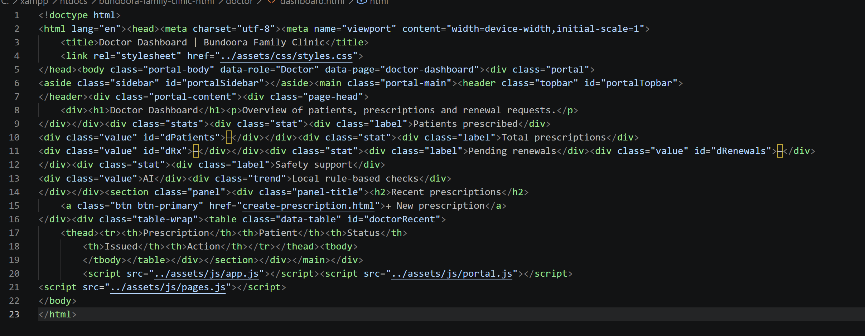

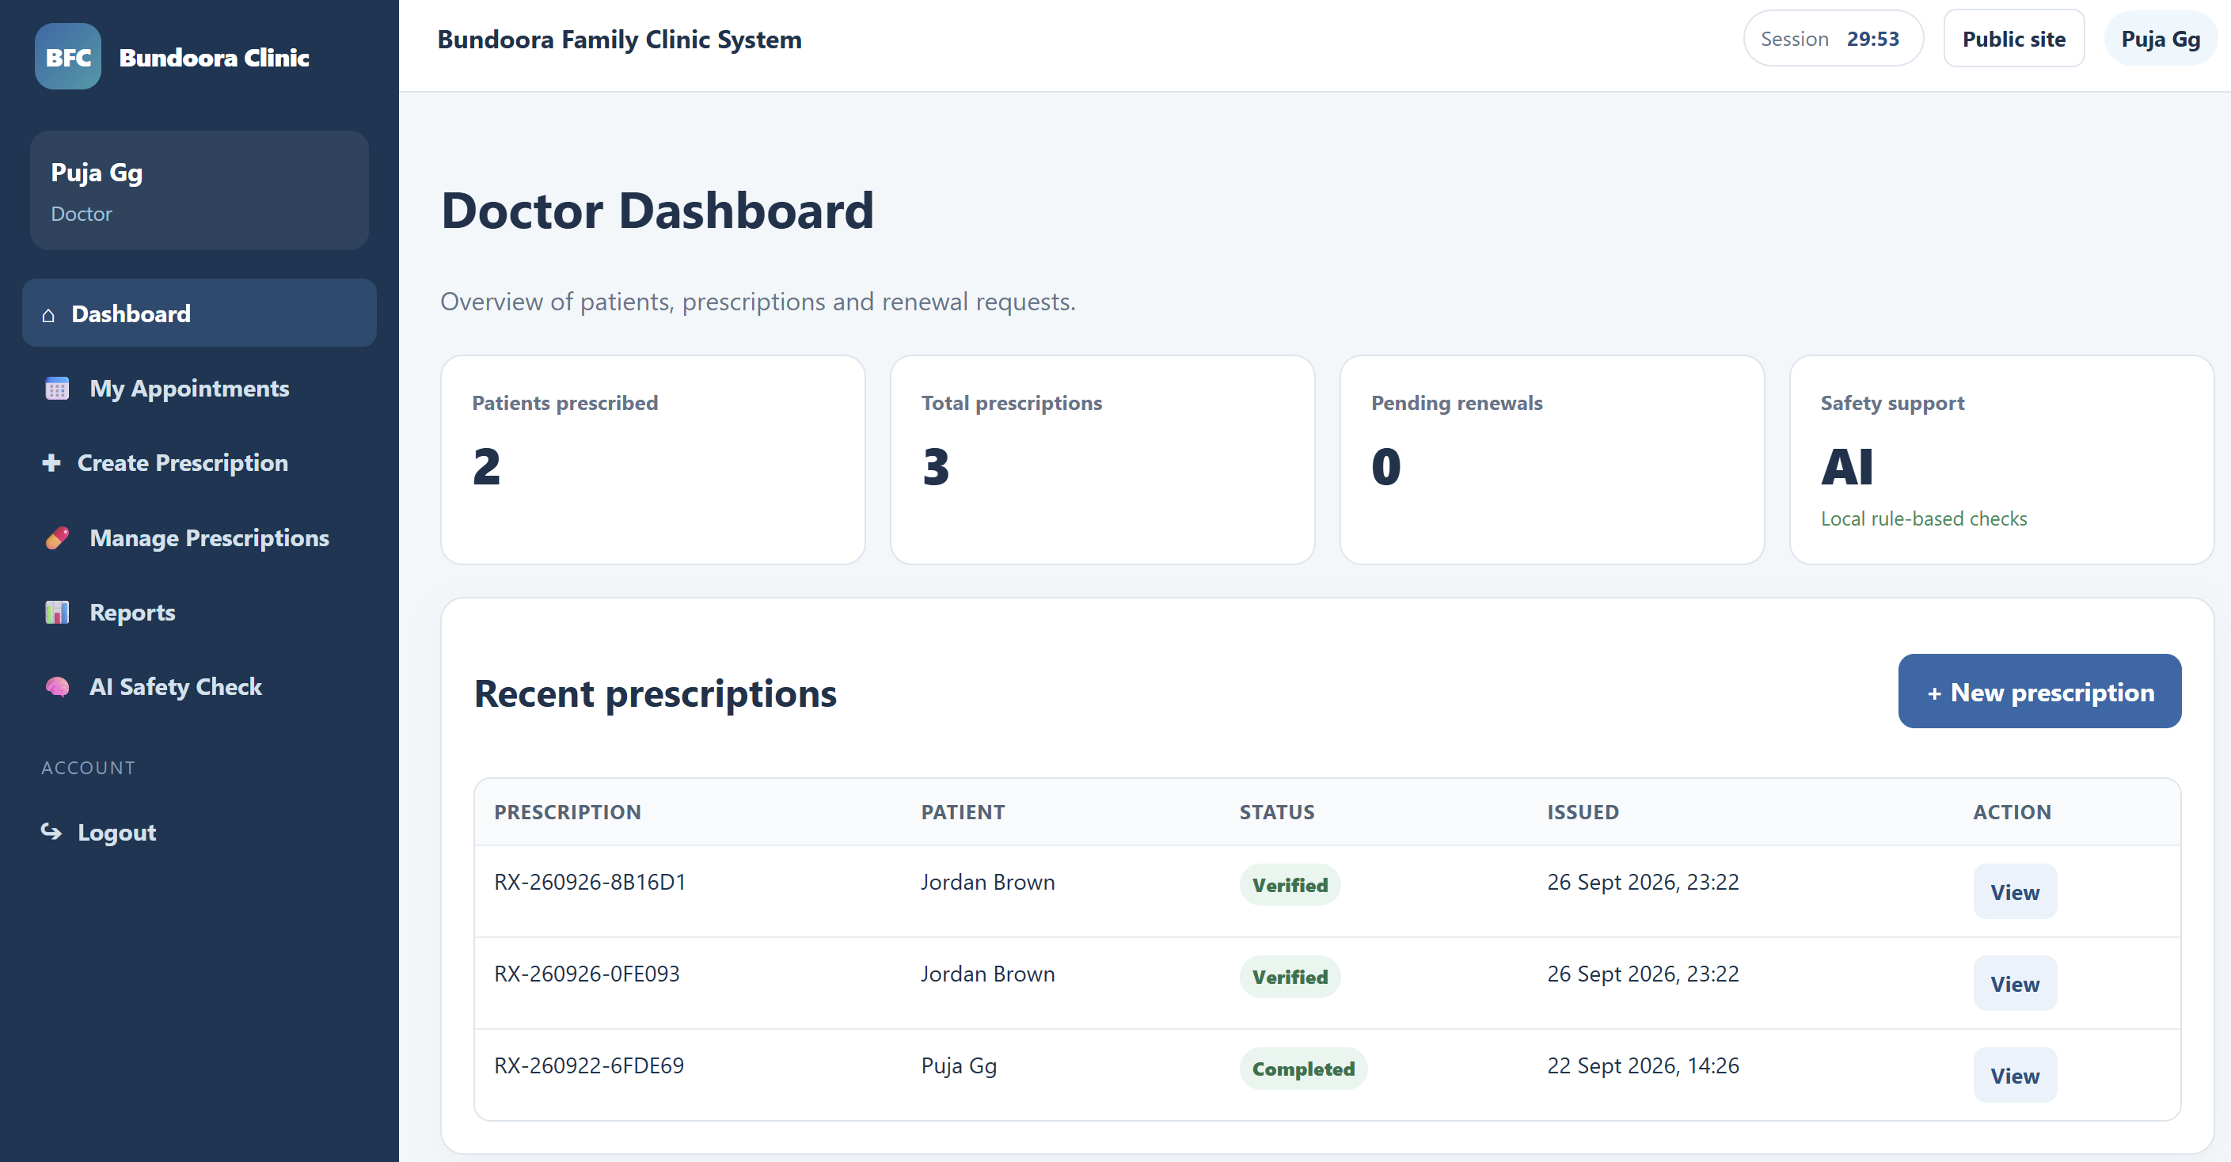Fig: Doctor dashboard

3.2 Managing Patient Appointments

[Code]
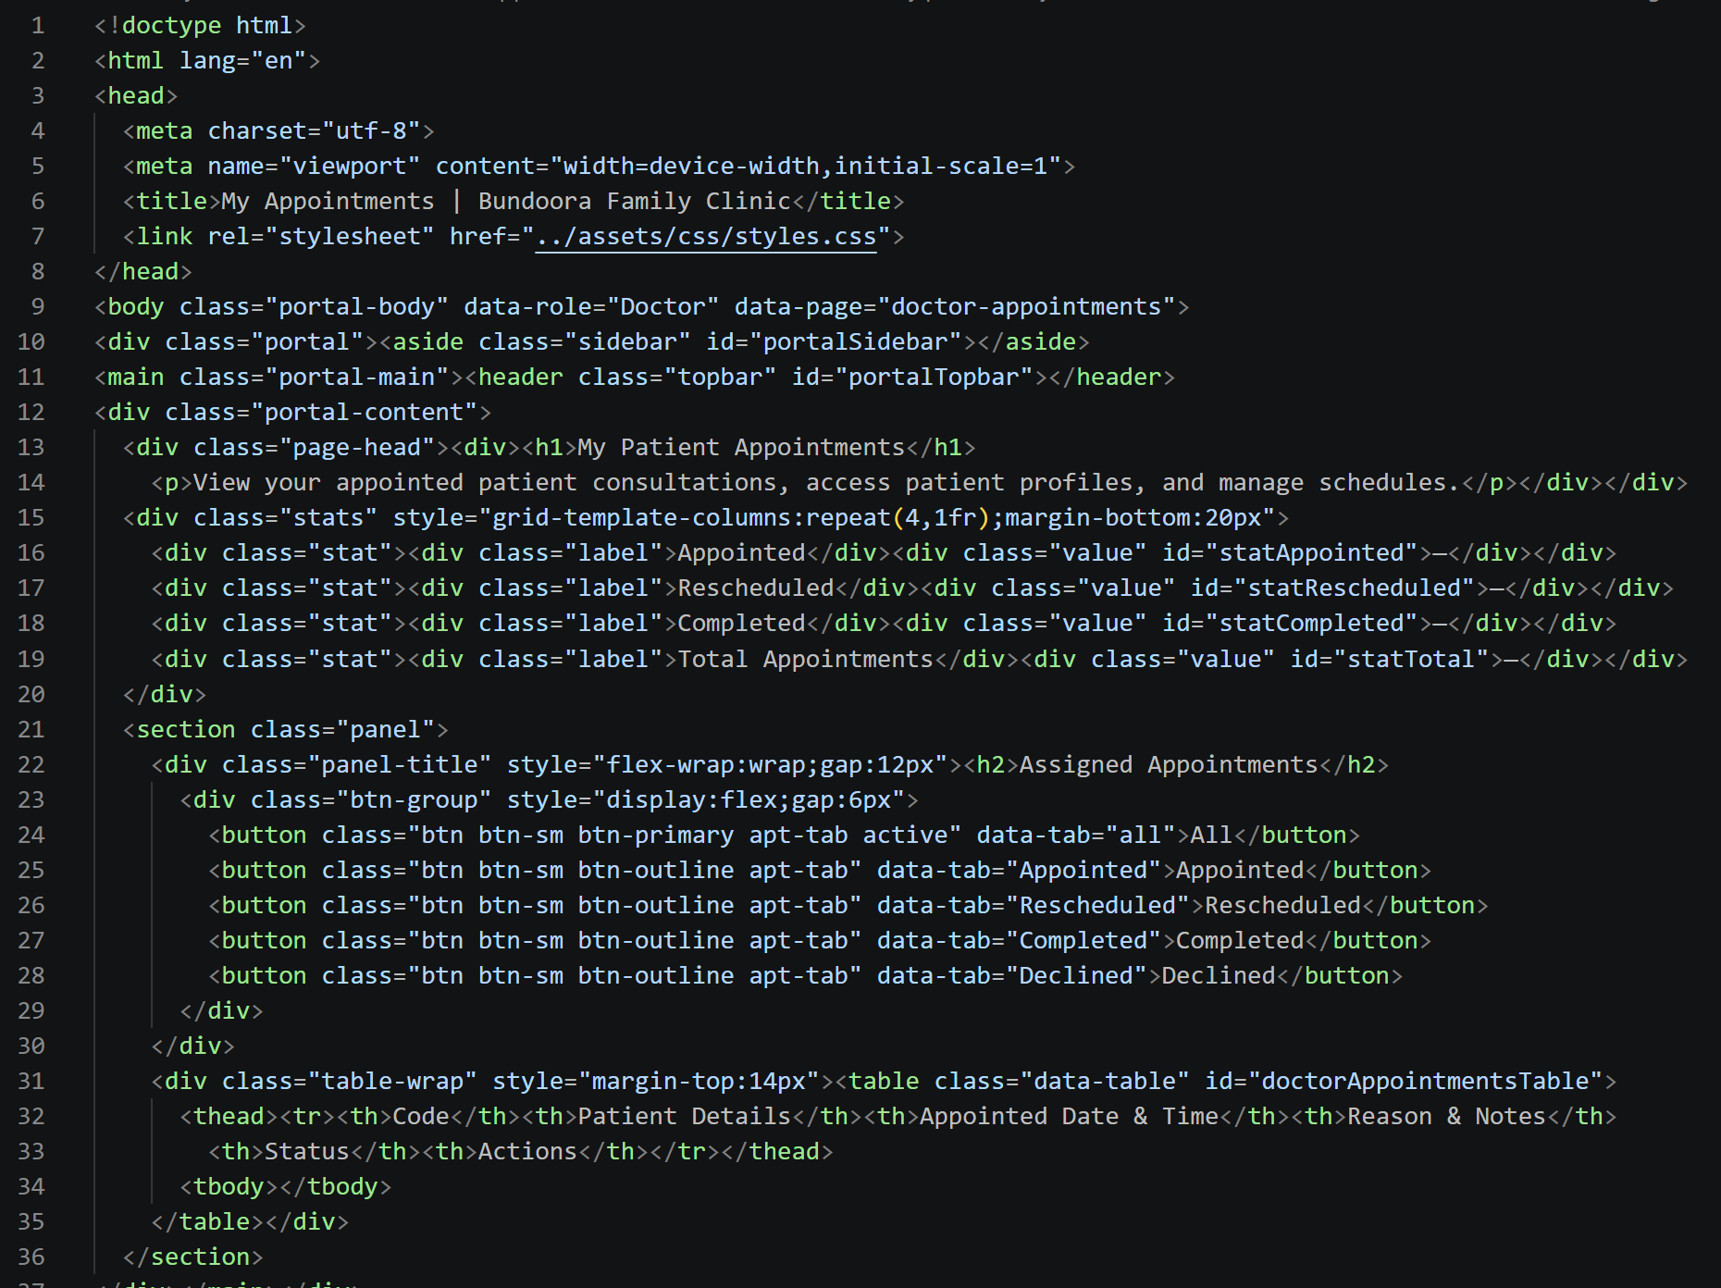

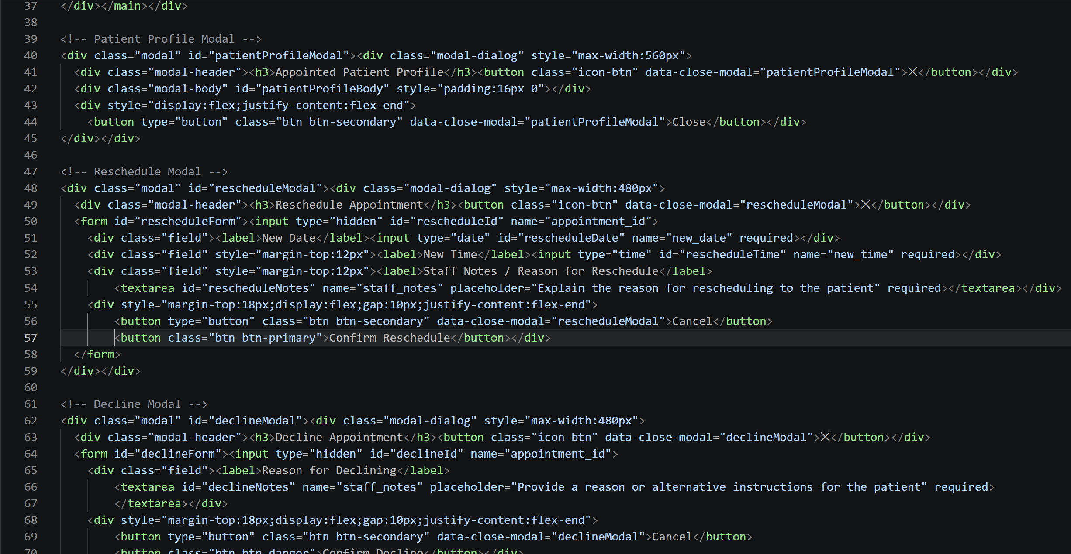
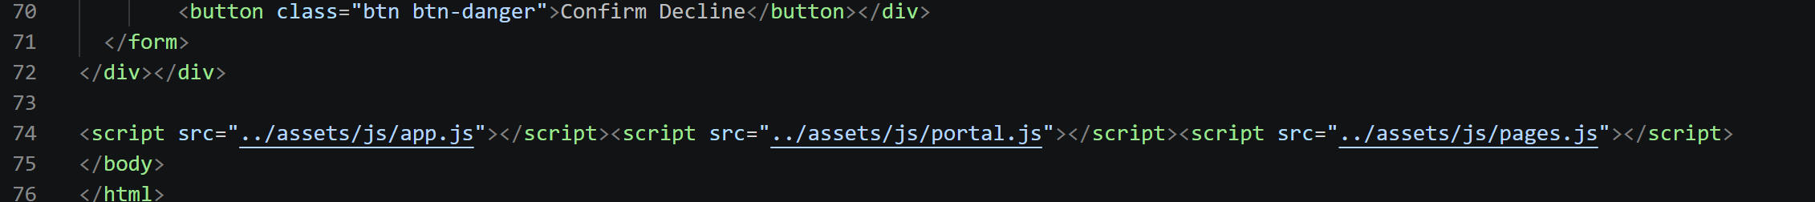
Select My Appointments to view appointments assigned to you. Use the filter tabs (All, Appointed, Rescheduled, Completed, Declined) to narrow the list.
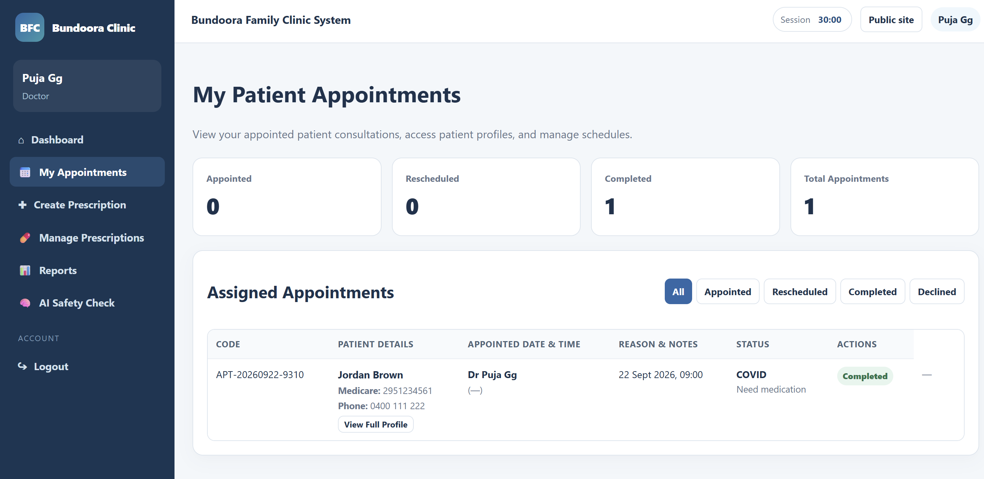Figure 12: My Patient Appointments with filter tabs

3.3 Creating and Signing a Prescription

[Code]
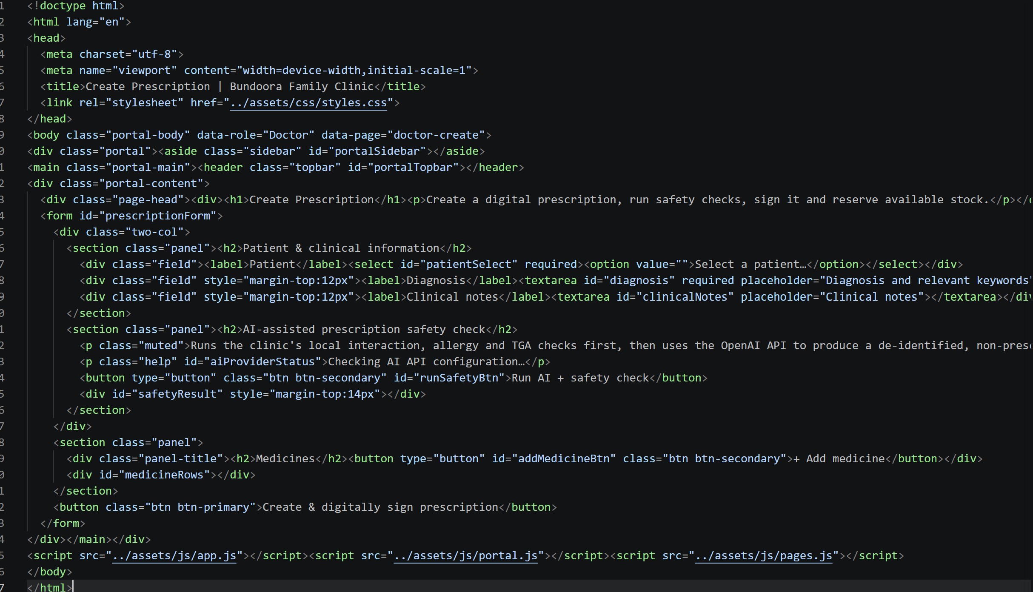

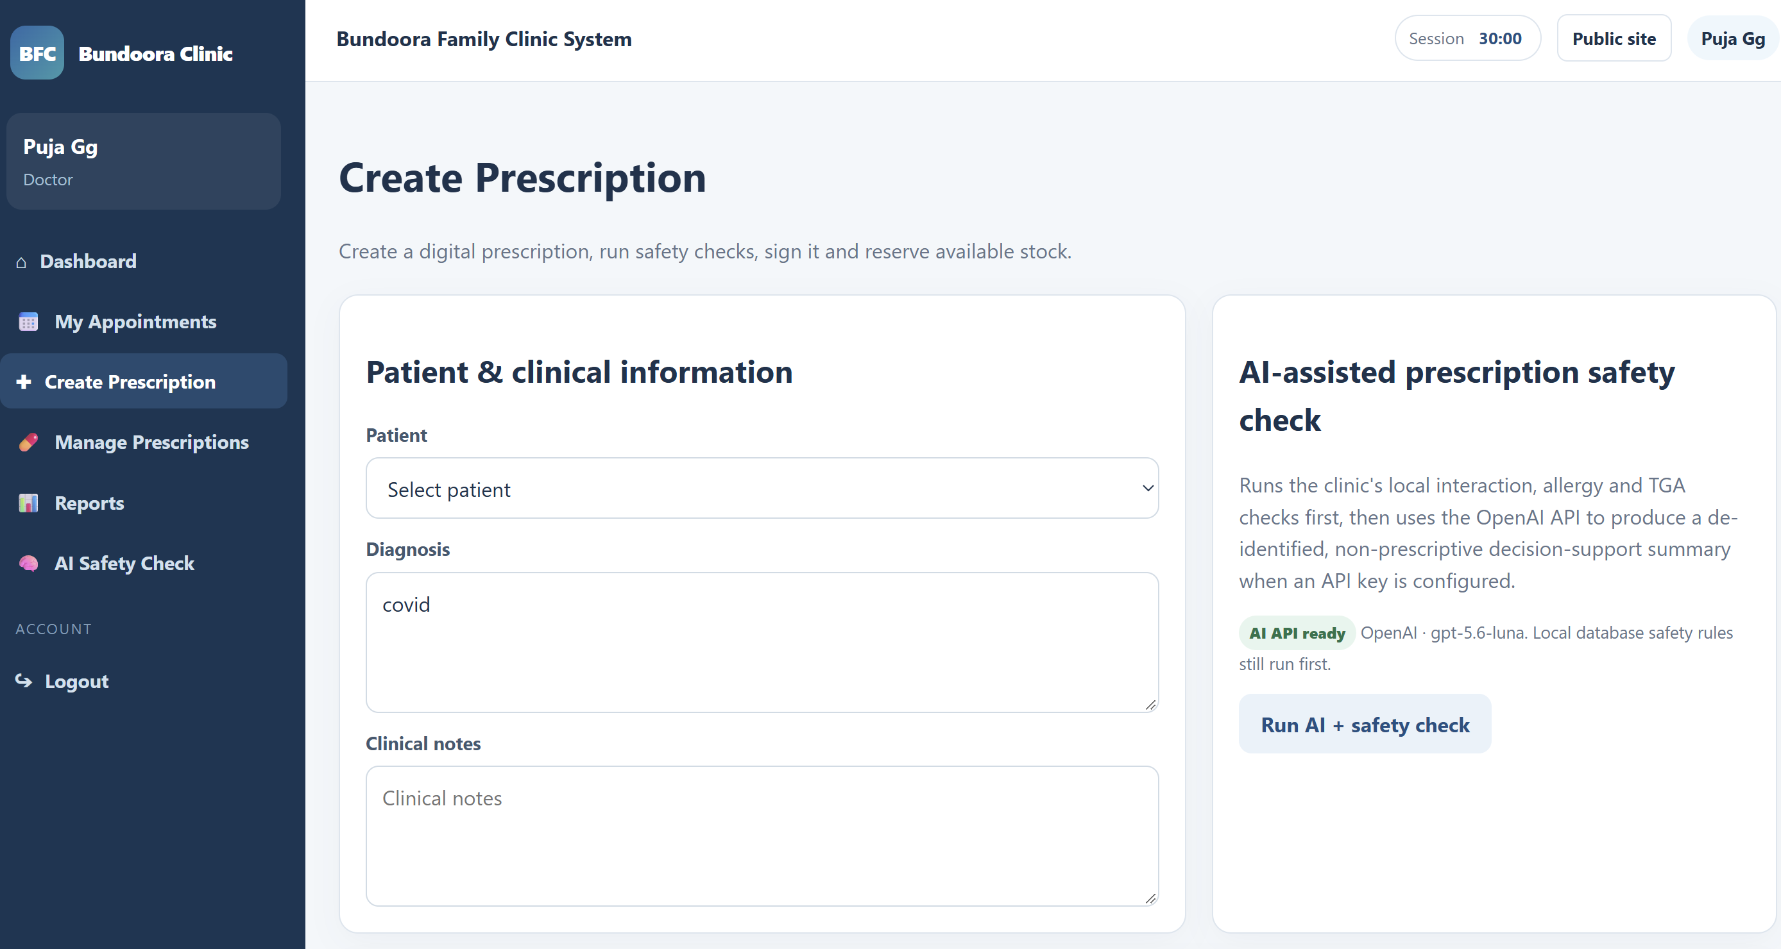 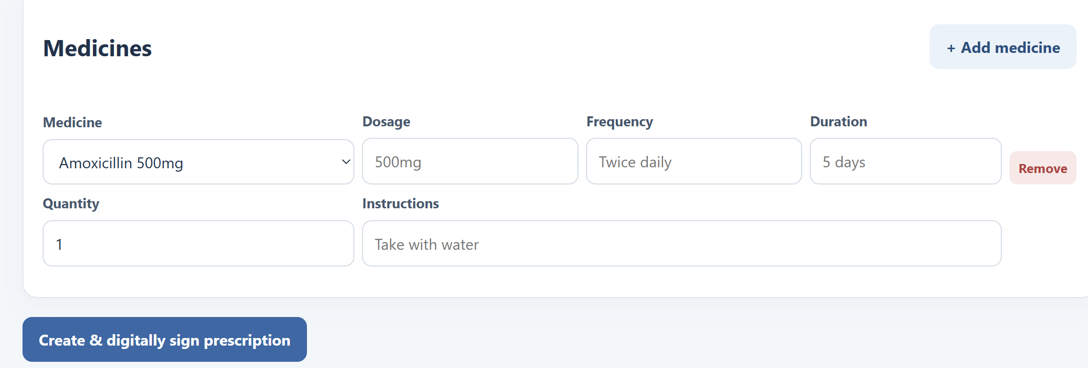Fig: Create Prescription form

3.4 AI Prescription Safety Check

[Code]
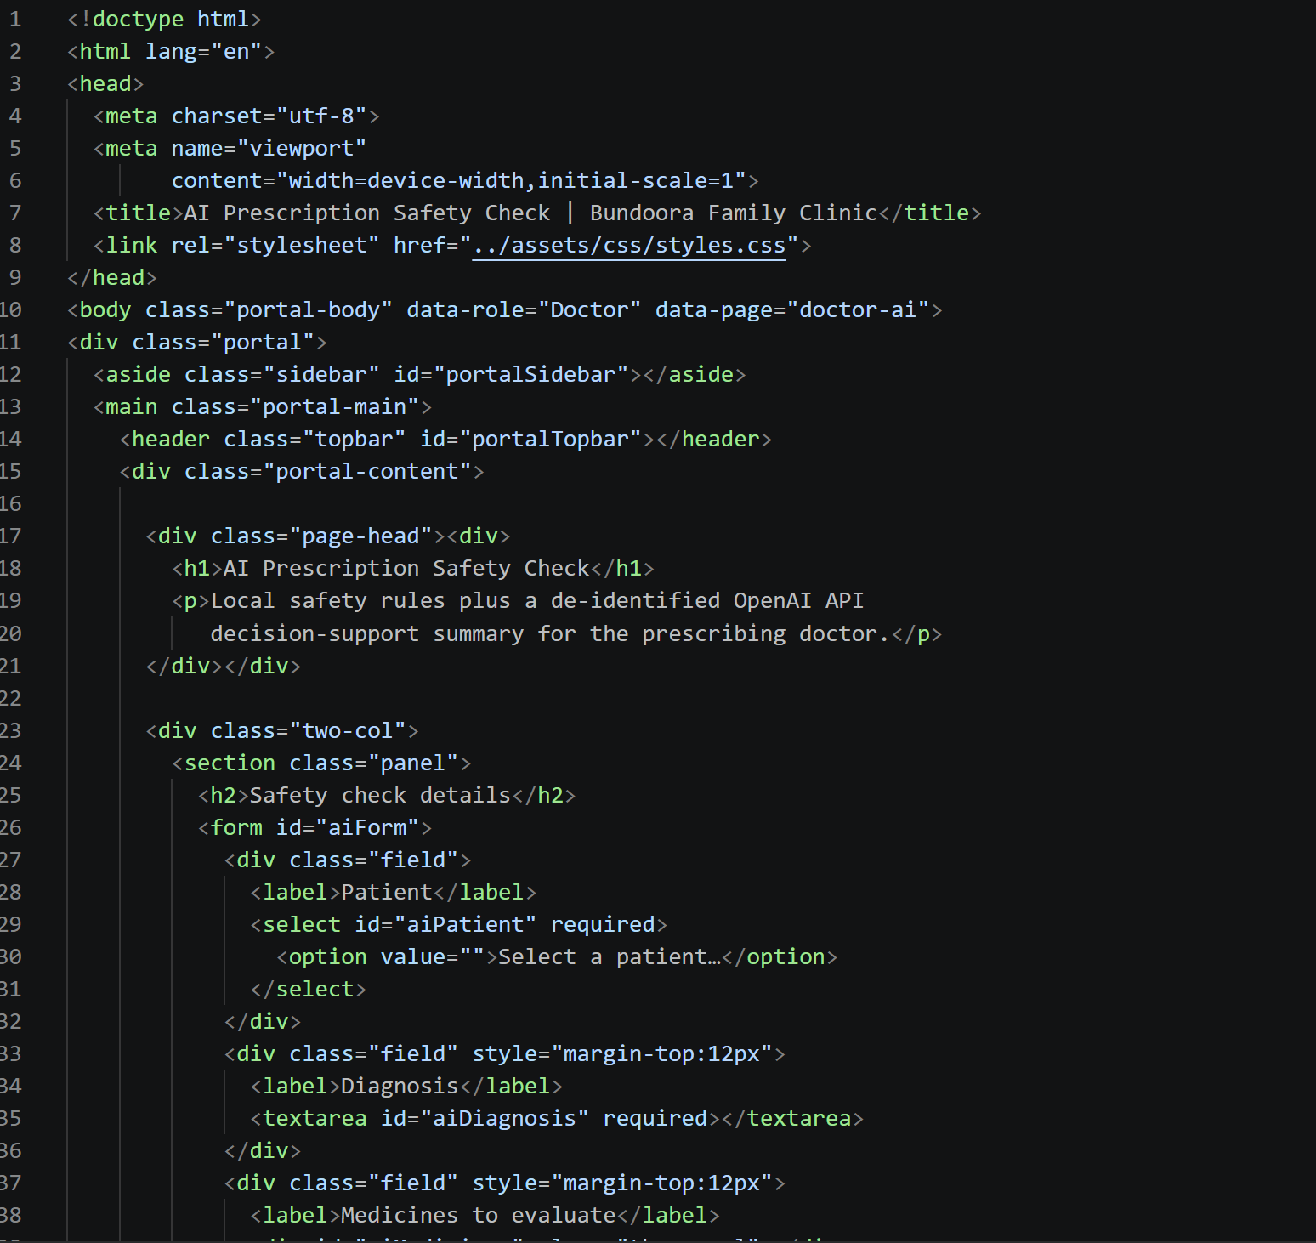
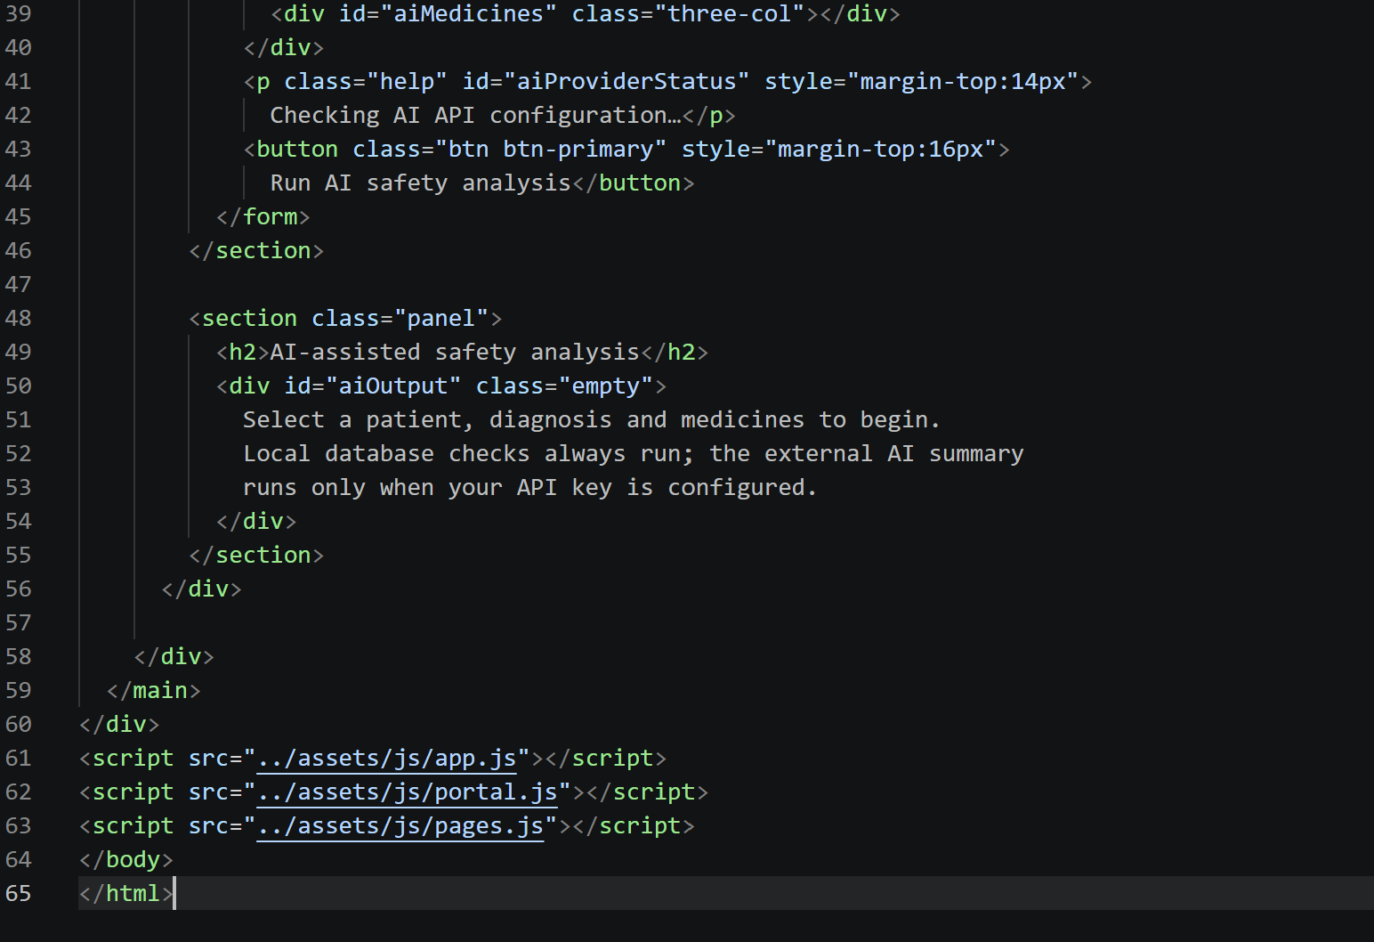

The safety check combines the clinic's own rules with an optional AI-generated summary. The local rules always run and cannot be overridden by the AI output.
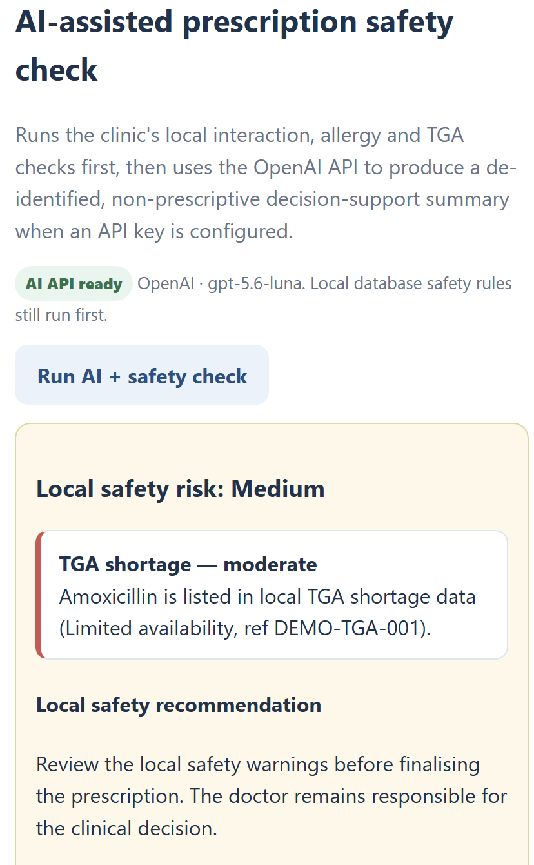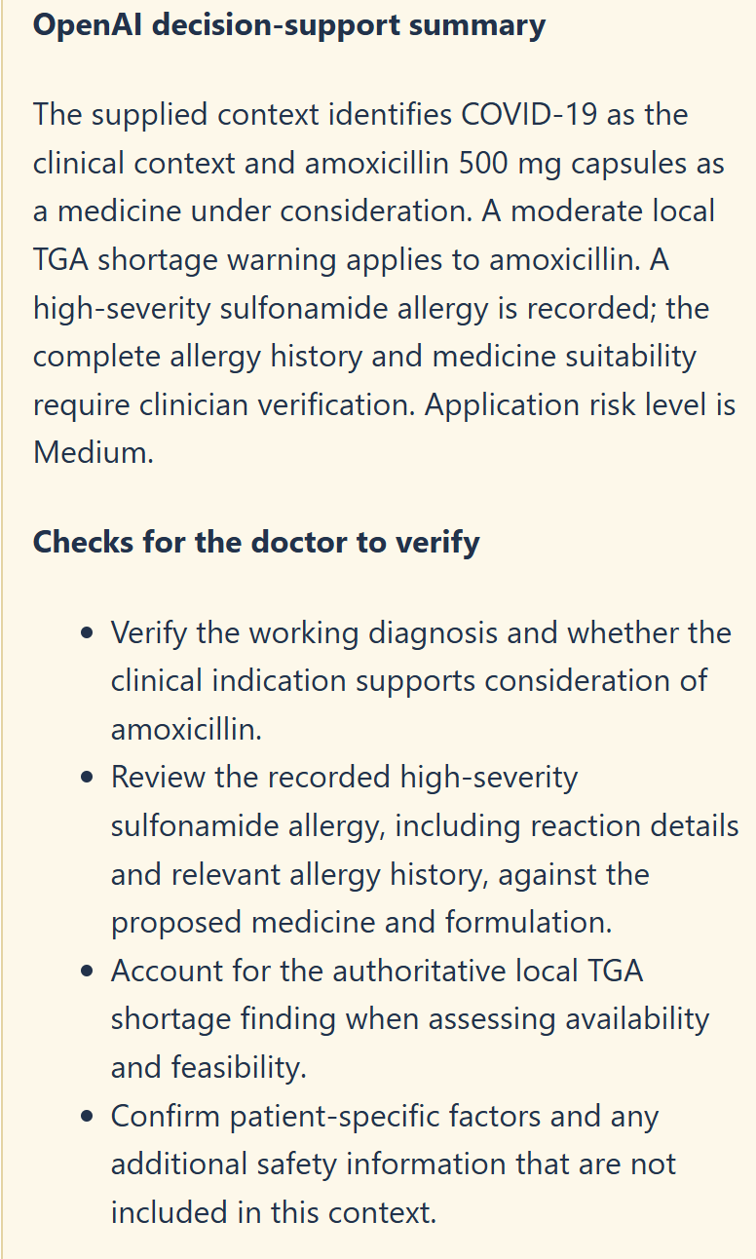
Fig: AI Prescription Safety Check results

3.5 Managing Prescriptions and Renewals

[Code]

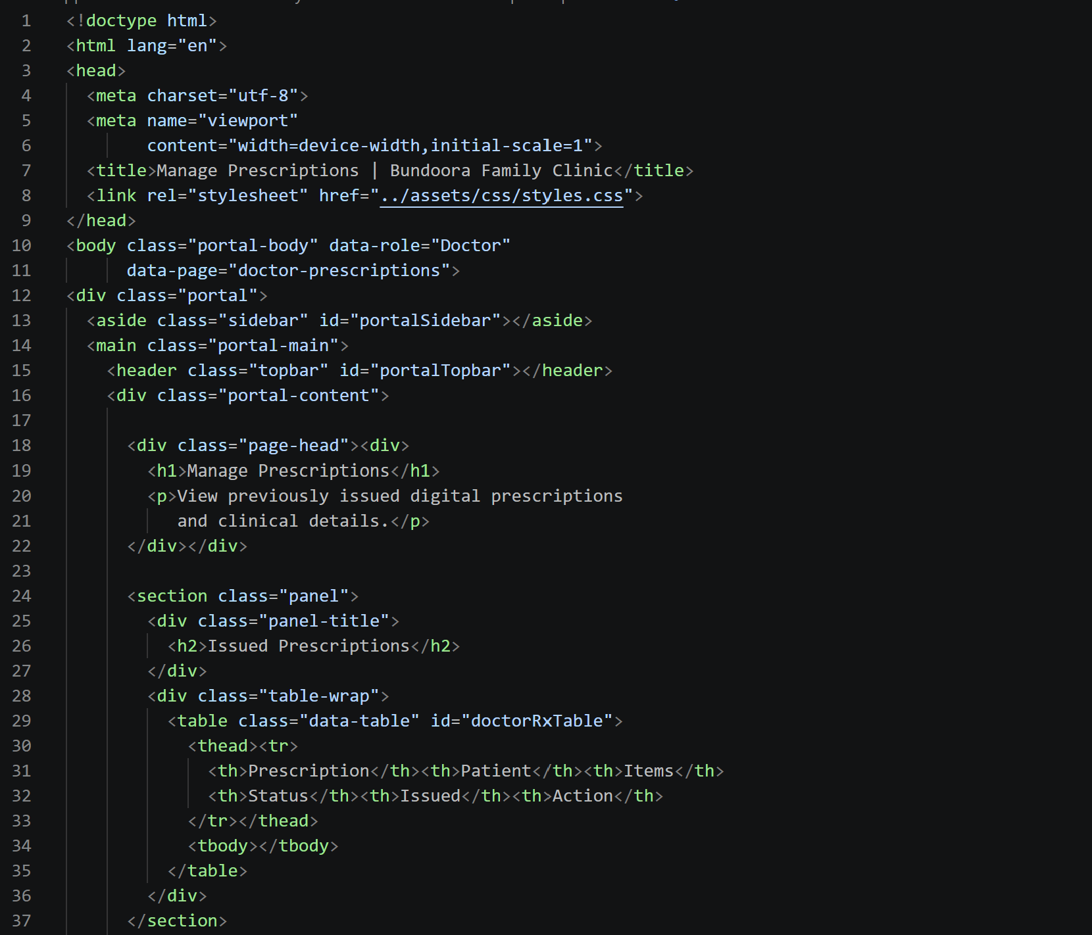
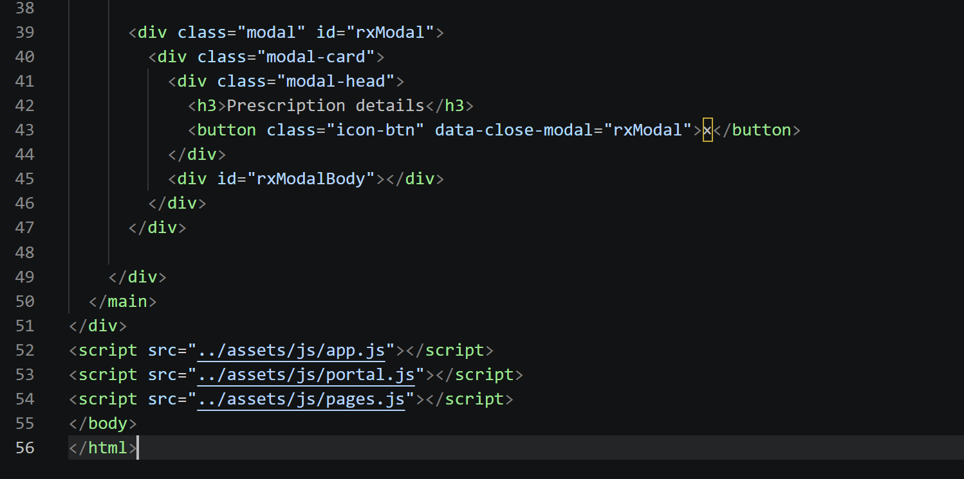
Select Manage Prescriptions to view issued prescriptions and open their details. Select Renewal Requests to approve or reject patient requests.
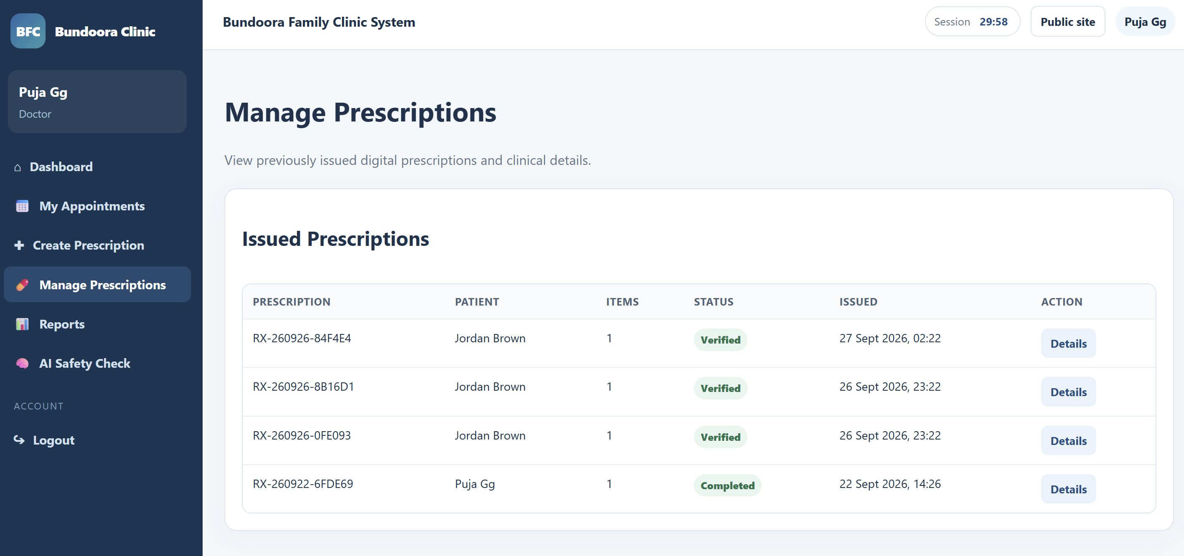
Fig: Managing prescription and renewal board

3.6 Reports

[Code]
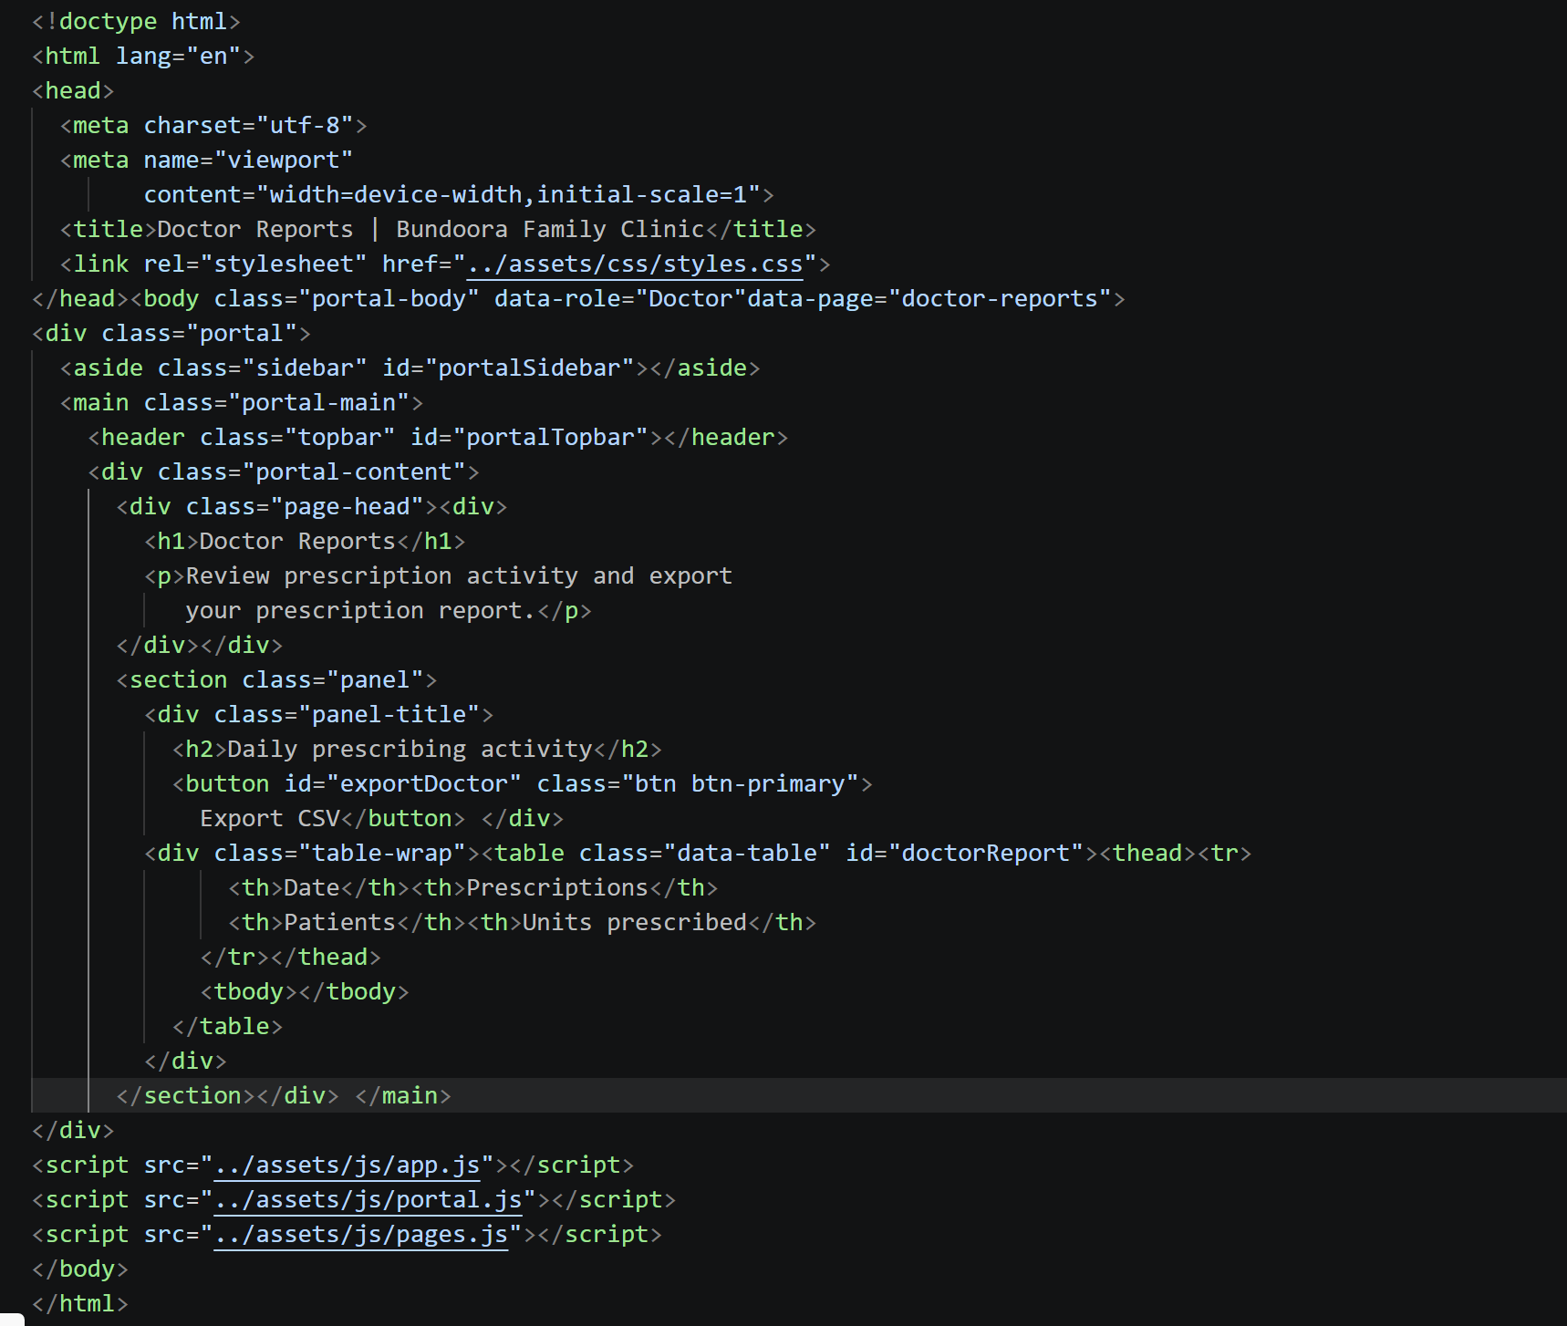

Select Doctor Reports to view daily prescribing activity (prescriptions, patients and units prescribed for the last 30 days) and select Export CSV to download the data.
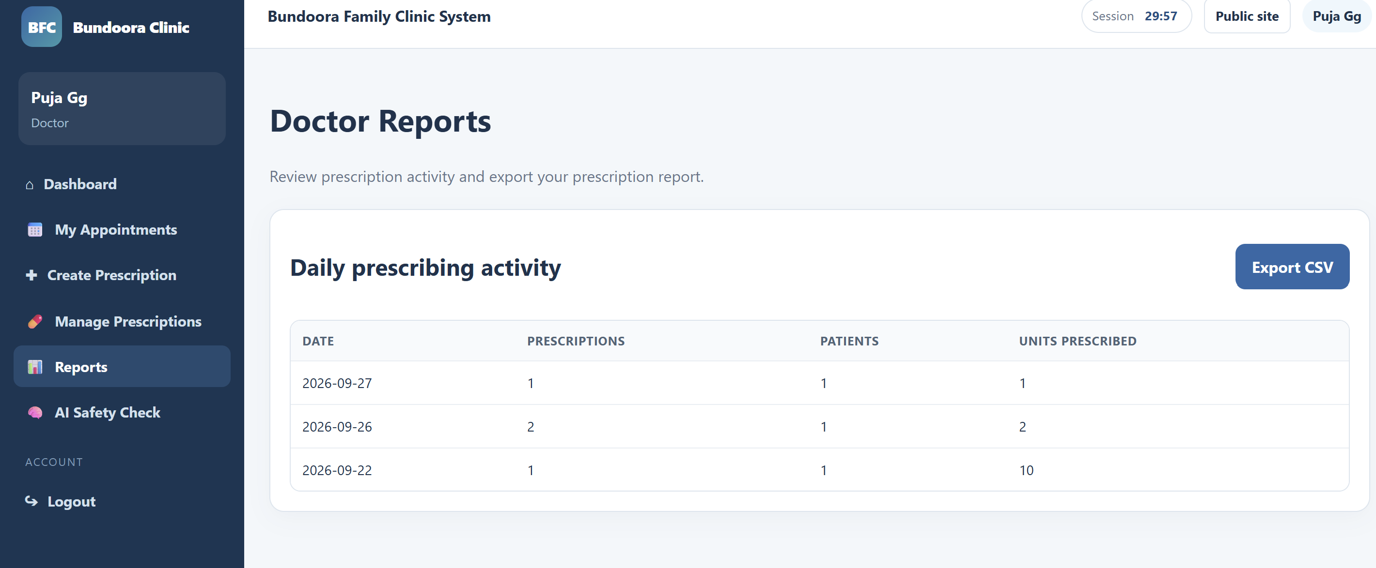
Fig: Review prescription and reports

